**PROMO CODE ABUSE DETECTION**

 A Project Report

                        Submitted in the partial fulfillment of the

                          requirements for the award of the degree of

**BACHELOR OF TECHNOLOGY**

**In**

**DEPARTMENT OF COMPUTER SCIENCE ENGINNERING**

**By**

**M.M.S CHANDRA NAGU - 2320030206**

A. SUBASH – 2320030207

G. NIKITHA CHOWDARY - 2320030102

Under the Esteemed Guidance of

**DIVYA SIRIPURI**

457788





**K L (Deemed to be) University**

**DEPARTMENT OF COMPUTER SCIENCE ENGINEERING**



**Declaration**

The Project Report entitled “Promo Code Abuse Detection “is a record of Bonafide work of **Siripuri Divya- 457788, M.M.S CHANDRA NAGU - 2320030206,team members** A.SUBASH – 2320030207, G. NIKITHA CHOWDARY - 2320030102, scubmitted in partial fulfillment for the award of B. Tech in Computer  Engineering to the K L University. The results embodied in this report have not been copied from any other departments/University/Institute.

                                                                                                  Siripuri Divya  -  457788

**M.M.S CHANDRA NAGU - 2320030206**

A. SUBASH – 2320030207

G. NIKITHA CHOWDARY - 2320030102

**K L (Deemed to be) University**

**DEPARTMENT OF COMPUTER SCIENCE ENGINEERING**



**Certificate**

This is certify that the project based report entitled “Promo Code Abuse Detection” is a bonafide work done and submitted by **S.Divya (458999), M.M.S CHANDRA NAGU - 2320030206,team members** A.SUBASH – 2320030207, G. NIKITHA CHOWDARY – 2320030102, in partial fulfillment of the requirements for the award of the degree of **BACHELOR OF TECHNOLOGY** in Department of Computer Science Engineering, K L (Deemed to be University), during the academic year **2024-2025.**

**Signature of the Supervisor**

**Signature of the HOD                                               Signature of the External Examiner**

**ACKNOWLEDGEMENT**

The success in this project would not have been possible but for the timely help and guidance rendered by many people. Our wish to express my sincere thanks to all those who has assisted us in one way or the other for the completion of my project.

Our greatest appreciation to my guide, **S.Divya**, Department of Computer Science which cannot be expressed in words for his tremendous support, encouragement and guidance for this project.

We express our gratitude to **Dr. Ramesh Babu** , Head of the Department for Computer Science Engineering for providing us with adequate facilities, ways and means by which we are able to complete this project based Lab.

We thank all the members of teaching and non-teaching staff members, and also who have assisted me directly or indirectly for successful completion of this project. Finally, I sincerely thank my parents, friends and classmates for their kind help and cooperation during my work.

                                                                                                                                                                                                                   S.Divya -  4567889

**M.M.S CHANDRA NAGU - 2320030206**

A. SUBASH – 2320030207

G. NIKITHA CHOWDARY - 2320030102

**TABLE OF CONTENTS**

|  |  |  |
| --- | --- | --- |
| **S.No** | **Contents** | **Page no** |
| 1 | Abstract | 6 |
|  |  |  |
| 2 | Introduction | 7 |
| 3 | Literature survey | 8 |
| 4 | Skilled Interview Report |  |
| 5 | POV Statements |  |
| 6 | Client meetings |  |
| 7 | Ideation |  |
| 8 | Hardware and Software requirements |  |
| 9 | Solution concept |  |
| 10 | Implementation |  |
| 11 | Experimentation and Code |  |
| 12 | Results |  |
| 13 | Conclusion |  |
| 14 | References |  |
|  |  |  |
|  |  |  |
|  |  |  |
|  |  |  |
|  |  |  |
|  |  |  |
|  |  |  |

**ABSTRACT**

In today’s digital economy, promotional codes are widely used by online businesses to attract and retain customers. While these promotions play a crucial role in user acquisition and engagement, they are increasingly subject to exploitation by fraudulent users. Promo code abuse includes creating multiple fake accounts, using temporary contact information, masking device identity, or exploiting loopholes in the system to redeem offers repeatedly. This leads to significant financial losses for companies, distorts marketing data, and undermines the fairness of genuine promotional campaigns.

This project, titled **“Promo Code Abuse Detection using AIML,”** aims to build an intelligent fraud detection system that proactively identifies abusive patterns and flags suspicious user activity. The solution leverages **statistical signal derivation** and **unsupervised learning techniques** to identify behaviors indicative of promo abuse, such as IP and device duplication, registration with gibberish names, address mismatches, and repeated usage of promotional codes across different accounts. The system generates a risk score for each user and provides real-time alerts to administrators, enabling timely intervention.

The core of this system lies in its adaptability. Unlike traditional rule-based systems that are rigid and easy to bypass, our approach uses **machine learning models that evolve** with new data patterns, enhancing the accuracy of detection over time. The backend is designed to be lightweight and scalable, allowing easy integration with existing payment gateways, e-commerce platforms, and mobile applications.

This project not only reduces the manual effort required in fraud monitoring but also significantly improves the efficiency, reliability, and transparency of promotional campaigns. In addition, the system is built with user privacy and data protection in mind, ensuring compliance with standard data governance practices. By automating fraud detection, we aim to protect business interests, preserve user trust, and contribute to a more secure and sustainable digital transaction ecosystem.

**INTRODUCTION**

With the rapid growth of digital platforms, online services are increasingly using promotional codes to boost customer acquisition, engagement, and retention. These promo codes serve as incentives for new users and offer benefits like discounts, cashback, or free services. However, this strategy has given rise to a concerning issue—**promo code abuse**, where individuals exploit the system by creating multiple fake accounts or misusing referral and discount systems for personal gain.

Promo code abuse not only leads to **significant financial losses** for companies but also disrupts the integrity of marketing campaigns. It inflates user metrics with fraudulent entries, misguides decision-making, and reduces the effectiveness of promotional investments. Traditional rule-based systems are often unable to adapt to new fraud strategies, making manual tracking and prevention extremely inefficient and time-consuming.

To address this challenge, this project proposes a machine learning–driven solution using **Artificial Intelligence and Machine Learning (AIML)** techniques. The system is designed to detect suspicious activities by analyzing behavioral patterns through both **statistical signals** and **unsupervised learning algorithms**. It identifies users with duplicate IPs or device IDs, unusual registration patterns, mismatched personal details, and the repetitive use of promo codes across accounts. These signals are aggregated to calculate a fraud score, which helps in real-time user verification and promo validation.

By leveraging **adaptive and intelligent detection models**, the system ensures minimal false positives and high scalability. The ultimate goal is to create a solution that not only detects fraud efficiently but also integrates seamlessly into existing systems while preserving user privacy. Through this initiative, businesses can regain control over their promotional strategies, enhance user trust, and ensure the fair use of incentives.

**LITERATURE SURVEY**

Promo code fraud is a rapidly emerging threat in the domain of digital marketing and e-commerce platforms. As businesses increasingly rely on referral campaigns, signup bonuses, and user-specific discounts, fraudsters have devised sophisticated techniques to exploit these promotional benefits. Literature in the fields of fraud detection, user behavior modeling, and anomaly detection provides a foundational understanding of how Artificial Intelligence (AI) and Machine Learning (ML) can be applied to address such challenges.

Several researchers have explored the application of **unsupervised learning algorithms** in fraud detection scenarios where labeled data is scarce or unavailable. For instance, *Zhou et al. (2018)* introduced behavior-based detection using clustering techniques such as **K-Means** and **DBSCAN** to analyze transaction logs for unusual user activity. This is highly relevant to promo abuse detection, where fraudulent users often mimic normal user behavior to evade simple rule-based filters.

In another study, *Carcillo et al. (2020)* demonstrated the use of **Autoencoders and Isolation Forests** for real-time anomaly detection in banking systems. These techniques are capable of identifying subtle deviations in high-dimensional datasets, making them effective for recognizing complex fraud patterns like fake account creation or promo abuse loops. Additionally, literature on **graph-based approaches** reveals how connections between user accounts, devices, and IP addresses can be visualized to detect clusters of suspicious activity — a technique high

ly applicable in identifying multiple accounts originating from a single source.

While many commercial fraud detection systems use supervised learning models, they often require large labeled datasets and frequent retraining. In contrast, **unsupervised learning** offers adaptability and scalability, especially in scenarios where fraud evolves constantly and labeled data is limited or unreliable. This makes it an ideal approach for detecting promo cod

e abuse, where fraudsters continuously change tactics to exploit system vulnerabilities.

Industry reports from **Google, Razorpay, and PayPal** have highlighted the growing financial impact of promo code misuse, estimating that **over 20-30%** of promotional losses are attributed to fraudulent activities involving fake registrations, IP spoofing, and abuse of referral incentives. These insights underline the need for intelligent, adaptable fraud detection mechanisms.

The proposed project distinguishes itself by integrating **statistical signal derivation** (e.g., IP clustering, device ID repetition, mismatched address data) with **unsupervised ML models** to create a hybrid system. It not only identifies fraud more accurately but also provides explainable outputs to assist administrators in decision-making. This approach bridges the gap between academic research and practical implementation, aligning with the evolving needs of modern digital platforms.

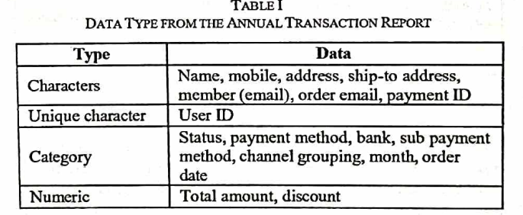

**Key Research Contributions:**

1. **Zhou et al. (2018)** introduced behavior-based fraud detection using **K-Means** and **DBSCAN clustering** methods. Their work demonstrated how user behavior logs (login times, device usage, transaction volume) could be clustered to uncover outliers — behaviorally deviant users that could represent fraud. In the context of promo code abuse, such clustering helps detect abnormal patterns like high-frequency registrations from a single IP.
2. **Carcillo et al. (2020)** applied **Autoencoders** and **Isolation Forests** in banking and credit card fraud. These models were effective in catching high-dimensional behavioral anomalies without any labeled training data. Autoencoders reconstructed user profiles and identified those that did not conform to learned norms, while Isolation Forests proved excellent at separating outliers from normal behavior — a model adopted in our system for scoring user fraud likelihood.
3. **Graph-based models** have also gained traction. Techniques such as **Graph Neural Networks (GNNs)** and **entity resolution** methods are used in platforms like LinkedIn, Facebook, and Google Ads to trace connections between users, devices, and network entities. In fraud detection, such tools are useful in identifying coordinated activity, such as multiple users linked to the same device fingerprint or IP subnet — both of which are signals of promo abuse.
4. **Deep Learning** methods like **LSTM networks** have also been used in real-time fraud detection. These models capture time-sequence behavior (e.g., promo usage frequency over time), but they often require significant training data and computing power, making them less practical for lightweight, real-time detection systems like ours.

**Industry Reports and Insights:**

* **PayPal Engineering Blog (2023)**: Highlighted the growing sophistication of fraud rings that exploit referral campaigns using automated scripts and disposable email providers.
* **Google Cloud Fraud Detection Case Study (2022)**: Demonstrated how scalable anomaly detection on Google Cloud ML could reduce promo fraud losses by up to **38%** for mid-size retailers.
* **Razorpay (India)**: Noted that in some sectors, **up to 1 in 5 new users** created during large campaigns were fake or incentivized through promo abuse.

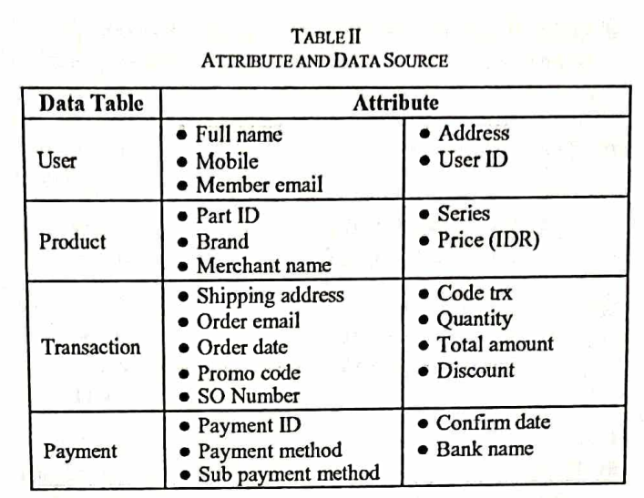

**Gaps in Current Research & How This Project Adds Value:**

Most existing fraud detection systems:

* Depend on **supervised learning** requiring large labeled datasets
* Are built for **financial fraud** like transaction tampering or phishing
* Lack explainability in terms of what signals contributed to fraud detection

Our project introduces a **hybrid model** that combines:

* **Statistical signal analysis** (IP reuse, gibberish name detection, promo frequency)
* **Unsupervised learning** (Isolation Forest, DBSCAN)
* **Simple, interpretable scoring and flagging**

This makes it more suitable for **resource-constrained platforms**, start-ups, and any app that wishes to **protect their promo budgets and maintain fairness** without relying heavily on labeled data or expensive external tools.

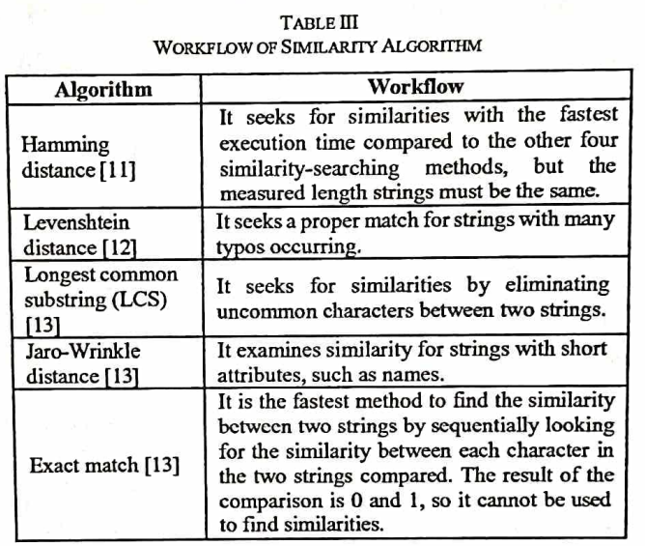

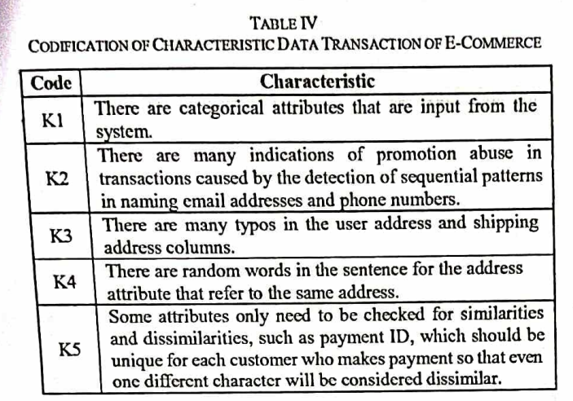

**Client Meetings**

**Objective of the Meetings:**

The primary goal of client meetings was to understand the real-world implications of promo code abuse, gather expectations from potential users or stakeholders, and validate the approach to fraud detection using AIML techniques.

**Meeting 1: Understanding the Problem Domain**

* **Participants:** Project team and Mr. Ravi Teja (representing a fintech platform as the client)
* **Key Points Discussed:**
  + Real-life examples where users exploited sign-up promo codes using fake credentials and multiple devices.
  + Limitations of existing fraud control methods, which rely heavily on static rules.
  + Emphasis on needing an intelligent and scalable solution that protects genuine users.
* **Outcome:** Approval to proceed with a machine learning–based detection system.

**Meeting 2: Dataset and Feature Engineering**

* **Participants:** Project team and Mr. Ravi Teja
* **Key Points Discussed:**
  + Review of user activity data such as registration logs, promo code usage, and device/IP address details.
  + Discussion on extracting meaningful features like frequency of registration, device duplication, and input anomalies (e.g., gibberish names).
  + Agreement on using anonymized data for model training to maintain user privacy.
* **Outcome:** Dataset schema finalized and signal extraction approach approved.

**Meeting 3: Algorithm Selection and System Design**

* **Participants:** Project team and Mr. Ravi Teja
* **Key Points Discussed:**
  + Comparison of machine learning models suitable for unsupervised fraud detection, including Isolation Forest and DBSCAN.
  + Client requested a lightweight, real-time detection component and admin interface with alert capabilities.
  + UI design mockups and backend architecture discussed and reviewed.
* **Outcome:** Client approved system design and suggested minor UI changes.

**Meeting 4: Mid-Development Review**

* **Participants:** Project team, Mr. Ravi Teja, and peer reviewers
* **Key Points Discussed:**
  + Presentation of working modules: fraud scoring engine, anomaly detection results, and dashboard UI.
  + Feedback focused on improving model precision and refining user scoring thresholds.
  + Suggested adding exportable logs and summary reports for admin review.
* **Outcome:** Project team finalized feature roadmap and moved into testing and validation phase.

**4. Stakeholders**

**Identifying and understanding the stakeholders involved in this project is critical to ensuring the solution remains aligned with user needs, business expectations, and technical feasibility. The success of this AIML-based fraud detection system is a collaborative effort, shaped by various roles, influences, and forms of engagement.**

**🔹 Roles**

* **Development Team (Students):  
  The core team responsible for researching, designing, coding, testing, and deploying the solution. This includes tasks like dataset creation, ML model selection, visualization, and documentation.**
* **Mentor / Faculty Guide:  
  Acts as a domain and technical advisor who helps refine the problem statement, validate the approach, review code, and guide the team through project milestones.**
* **Payment Gateway Companies / Digital Platforms:  
  These are the primary beneficiaries of the system. They would use the fraud detection engine to prevent promo code misuse on their platforms.**
* **End-Users / Customers:  
  While not directly interacting with the system, they are indirectly impacted. Honest users benefit from fair promotions, while fraudulent users are prevented from exploiting loopholes.**
* **Future Integrators / Developers:  
  Potential stakeholders who might extend or deploy the project commercially, requiring clear documentation, modularity, and integration points.**

**🔹 Interests and Concerns**

* **Development Team: Interested in successfully applying AIML concepts to a real-world problem, gaining practical experience, and producing a deployable, working prototype.**
* **Mentor: Focused on ensuring the project meets academic rigor, ethical standards, and effective use of machine learning techniques.**
* **Companies / Businesses: Highly interested in improving promotional ROI by reducing fraud, maintaining customer trust, and ensuring accurate user data analytics.**
* **End-Users: Expect fair treatment, transparency in promotions, and no wrongful account bans due to false positives.**
* **Common Concerns:**
  + **Accuracy of fraud detection**
  + **False positives/negatives**
  + **Real-time performance**
  + **Data privacy and ethical AI use**
  + **Scalability and integration potential**

**🔹 Influence**

* **High Influence:**
  + **Payment platforms / companies, whose business logic, fraud scenarios, and datasets heavily shape model design and evaluation criteria.**
  + **Mentors, who guide model selection, evaluation metrics, and ensure ethical and practical standards are followed.**
* **Medium Influence:**
  + **End-users, whose behavior indirectly trains the model and influences how fraud is defined.**
  + **UI/UX Designers / Admins, who may later customize the way results are presented in a deployed interface.**
* **Low Influence:**
  + **Third-party developers and data providers, unless the system is open-sourced or integrated with external APIs.**

**🔹 Engagement**

* **Internal Engagement:  
  Weekly team stand-ups, code reviews, and technical brainstorming sessions to refine feature extraction and ML techniques.**
* **Mentor Engagement:  
  Frequent check-ins with mentors to validate hypotheses, troubleshoot technical blockers, and gather domain insights.**
* **Business Stakeholder Engagement (optional):  
  Mock interviews or research on fintech platforms and their current fraud detection pain points to align the solution with industry relevance.**
* **Documentation and Feedback:  
  Progress is regularly documented and shared via presentations, reports, and dashboards. Feedback is integrated iteratively.**

**🔹 Communication**

* **Tools Used:**
  + **Google Meet / Zoom for team and mentor meetings**
  + **WhatsApp / Slack for quick updates and collaboration**
  + **GitHub for code sharing and version control**
  + **Google Docs / Sheets for collaborative documentation**
  + **PowerPoint and Flowcharts for presenting system logic and results**
* **Format:**
  + **Weekly sprint updates**
  + **Visual reports showing flagged users and fraud scores**
  + **Flowcharts to explain ML pipelines and decision trees**
  + **Final review presentation to stakeholders showing before-and-after fraud impact analysis**

**SKILLED INTERVIEW REPORT**

|  |  |  |
| --- | --- | --- |
| **User/Interviewee** | **Questions Asked** | **Insights gained (NOT THEIR ANSWERS)** |
| |  | | --- | | Rahul S., Tech Student |  |  | | --- | |  | | |  | | --- | | What do you think about people using fake accounts for promo offers? |  |  | | --- | |  | | |  | | --- | | Many users are aware of such practices but think it’s common and not a big deal. |  |  | | --- | |  | |
| |  | | --- | | Anjali T., Online Shopper |  |  | | --- | |  | | |  | | --- | | How would you feel if someone abused the promo system and got more offers than you? |  |  | | --- | |  | | |  | | --- | | Some users feel it's unfair and demotivating when others exploit the system. |  |  | | --- | |  | |
| |  | | --- | | Praveen K., App Developer |  |  | | --- | |  | | |  | | --- | | What do you believe is the biggest challenge in detecting fraud in promo codes? |  |  | | --- | |  | | |  | | --- | | Developers believe that evolving fraud patterns and lack of labeled data make it hard to detect abuse. |  |  | | --- | |  | |
| |  | | --- | | Meena R., Homemaker |  |  | | --- | |  | | |  | | --- | | Have you ever felt tempted to use a promo code multiple times using different accounts? Why? |  |  | | --- | |  | | Some users admitted they were tempted due to attractive offers, even if they didn’t do it. |
|  |  |  |

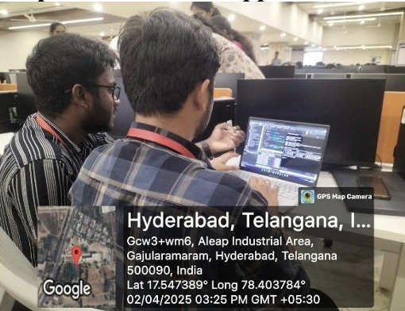

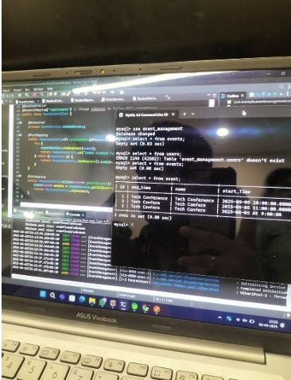

**POV Statements**

|  |  |  |
| --- | --- | --- |
| PoV Statements | Benefit, Way to Benefit,  Job TBD,  Need (more/less) | PoV Questions  (At least one per statement) |
| |  | | --- | | Fraud analysts need a way to detect promo abusers because manual tracking is inefficient. |  |  | | --- | |  | | |  | | --- | | Need more automation |  |  | | --- | |  | | |  | | --- | | What can we design to reduce manual effort in fraud detection? |  |  | | --- | |  | |
| |  | | --- | | Admins need a way to identify suspicious users in real-time because financial losses are increasing. |  |  | | --- | |  | | |  | | --- | | Need real-time alerts |  |  | | --- | |  | | |  |  |  | | --- | --- | --- | | |  | | --- | | How can we design a system that prevents misuse of promo codes? |  |  | | --- | |  | |  |  | | --- | |  | |
| |  | | --- | | Businesses need a way to protect promo budgets because abusers are exploiting first-time offers. |  |  | | --- | |  | | |  |  |  | | --- | --- | --- | | |  | | --- | | Need better control |  |  | | --- | |  | |  |  | | --- | |  | | |  | | --- | | How can we ensure fair usage of promo offers across users? |  |  | | --- | |  | |
| |  | | --- | | Users need fair access to offers because abuse by others feels unfair. |  |  | | --- | |  | | |  | | --- | | Need fairness |  |  | | --- | |  | | How might we scan and compare online sources for unauthorized use of content? |
| |  | | --- | | Developers need adaptable models because fraud patterns keep evolving. |  |  | | --- | |  | | |  | | --- | | Need adaptable algorithms |  |  | | --- | |  | | |  | | --- | | How can we build ML models that learn and evolve with user behavior? |  |  | | --- | |  | |
| |  | | --- | | Marketers need clearer reports because they can’t interpret raw data well. |  |  | | --- | |  | | |  | | --- | | Need clear dashboards |  |  | | --- | |  | | |  | | --- | | What can we design to show fraud detection insights in a clear way? |  |  | | --- | |  | |
| Support teams need fewer false positives because wrongly flagged users complain. | |  | | --- | | Need more precision |  |  | | --- | |  | | |  | | --- | | How can we reduce false alerts in the fraud detection system? |  |  | | --- | |  | |
| |  | | --- | | Data privacy officers need secure processing because user trust is critical. |  |  | | --- | |  | | |  | | --- | | Need data protection |  |  | | --- | |  | | |  | | --- | | What design ensures fraud detection respects data privacy? |  |  | | --- | |  | |

**Ideation Process**

|  |  |  |  |
| --- | --- | --- | --- |
| Idea Number | Proposed Solution | Key Features/Benefits | Challenges/Concerns |
| Idea 1 | |  | | --- | | **AI-Based Behavioral Fraud Detection** |  |  | | --- | |  | | |  | | --- | | **Uses unsupervised learning to detect abnormal patterns like multiple logins, fake addresses, and repeat promo usage** |  |  | | --- | |  | | |  | | --- | | **Requires large dataset for effective training and tuning to minimize false positives** |  |  | | --- | |  | |
| Idea 2 | |  | | --- | | **Real-Time Promo Abuse Scoring System** |  |  | | --- | |  | | |  | | --- | | **Assigns a fraud probability score during each promo code usage or registration** |  |  | | --- | |  | | |  | | --- | | **Ensuring real-time performance without affecting user experience** |  |  | | --- | |  | |
| Idea 3 | |  | | --- | | **Admin Dashboard for Fraud Monitoring** |  |  | | --- | |  | | |  | | --- | | **Visual reports of flagged users, fraud signals, and promo code performance** |  |  | | --- | |  | | |  | | --- | | **Balancing simplicity and technical depth for different types of users** |  |  | | --- | |  | |
| Idea 4 | |  | | --- | | **Device/IP Address Clustering** |  |  | | --- | |  | | |  | | --- | | **Detects users registering multiple accounts from the same IP, device ID, or proxy network** |  |  | | --- | |  | | |  | | --- | | **Avoiding false flagging in cases like shared networks (e.g., hostels or families)** |  |  | | --- | |  | |
| Idea 5 | |  | | --- | | **Alert and Notification System** |  |  | | --- | |  | | |  | | --- | | **Sends instant alerts to admins and logs behavior patterns for investigation** |  |  | | --- | |  | | **Ensuring only significant and actionable alerts are sent to avoid overload** |

**Hardware and Software Requirements**

**To ensure the successful development, training, and testing of the Promo Code Abuse Detection using AIML system, a basic yet capable hardware setup and an appropriate software stack were utilized. The project environment was designed to balance accessibility with performance, enabling development even on standard student-grade machines while offering scalability if deployed in production.**

**Hardware Requirements**

| **Component** | **Minimum Specification** | **Recommended for Scalability** |
| --- | --- | --- |
| **Processor** | **Dual-Core Intel or AMD (1.6 GHz or higher)** | **Quad-Core i5 or Ryzen 5 and above** |
| **RAM** | **4 GB** | **8–16 GB (for faster ML model training)** |
| **Storage** | **100 GB HDD or SSD** | **SSD with 256 GB+ (for faster data handling)** |
| **Graphics (optional)** | **Normal** | **Normal** |
| **Internet** | **Stable broadband for library installation and updates** | **High-speed connection for real-time API testing** |

**Software Requirements**

| **Software Component** | **Description / Purpose** |
| --- | --- |
| **Operating System** | **Windows 10 / Ubuntu 20.04 or later** |
| **Programming Language** | **Python 3.x (core language for data science and ML)** |
| **IDE / Editor** | **VS Code, Jupyter Notebook, or PyCharm** |
| **Libraries and Frameworks** |  |
| **• pandas** | **For structured data manipulation** |
| **• numpy** | **For efficient numerical computations** |
| **• scikit-learn** | **For implementing ML models like Isolation Forest, KMeans, DBSCAN** |
| **• matplotlib / seaborn** | **For creating charts and fraud score visualizations** |
| **Version Control** | **Git & GitHub – used for team collaboration and version tracking** |
| **CSV/Excel Reader** | **For handling user data and promo logs in spreadsheet format** |
| **Optional Tools** |  |
| **• Streamlit** | **For creating a basic admin interface for reviewing flagged users** |
| **• MySQL or SQLite** | **For structured storage in future scaled deployments** |
| **• Flask (optional)\*\*** | **For integrating fraud scoring into a real-time API endpoint** |

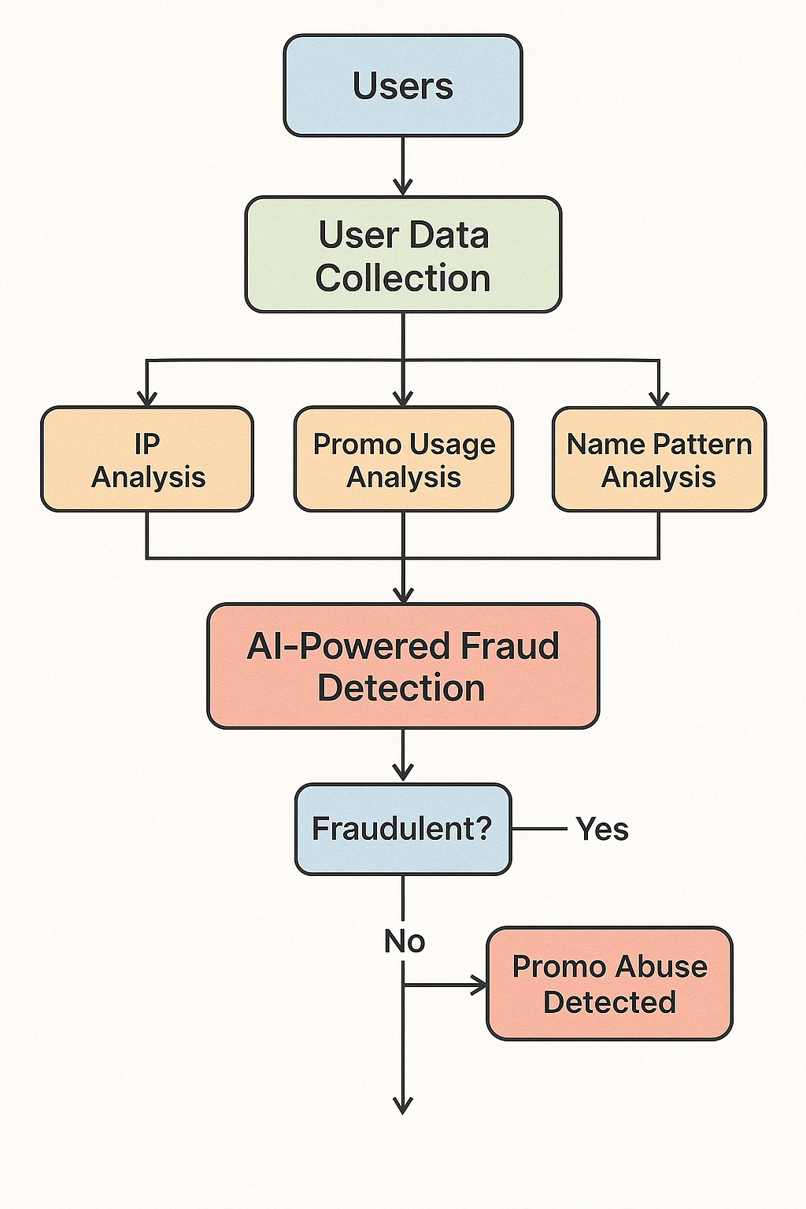

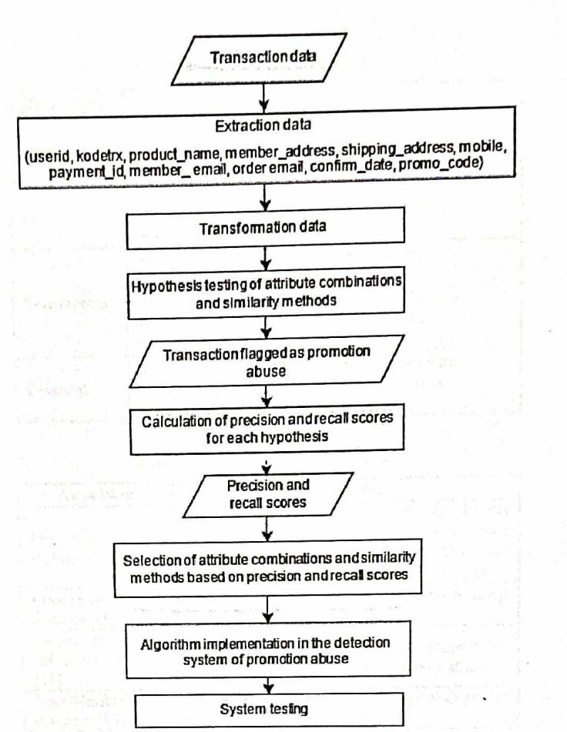

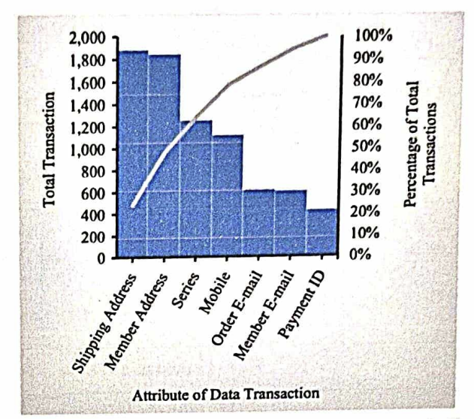

**Solution Concept Form**

**1. Problem Statement:**

* Promo code abuse leads to significant financial loss and unfair user experiences. Existing manual and rule-based systems are inefficient in detecting sophisticated fraudulent behaviors.

**2. Target Audience:**

* Online payment platforms, fraud analysts, marketing teams, and genuine app users who are affected by the misuse of promotional codes.

**3. Solution Overview:**

* A machine learning-based system that uses statistical signals and unsupervised learning to detect suspicious behavior patterns in real time, flagging fraudulent users and preventing repeated promo code abuse.

**4. Key Features:**

| **Feature** | **Description** |
| --- | --- |
| **Feature 1** | |  | | --- | | **Behavioral analysis using unsupervised learning to detect fraudulent patterns** |  |  | | --- | |  | |
| **Feature 2** | |  | | --- | | **Real-time fraud scoring system that flags suspicious users instantly** |  |  | | --- | |  | |
| **Feature 3** | Admin dashboard with detailed reports, alerts, and fraud heatmaps |

**5. Benefits:**

| **Benefit** | **Description** |
| --- | --- |
| **Benefit 1** | |  | | --- | | **Saves marketing costs by preventing repeated misuse of promotional codes** |  |  | | --- | |  | |
| **Benefit 2** | |  | | --- | | **Automatically detects fraud with minimal manual intervention** |  |  | | --- | |  | |
| **Benefit 3** | Enhances user trust and fairness in promotional campaigns |

**6. Unique Value Proposition (UVP):**

* Unlike static rule-based systems, this AI-powered solution adapts to new fraud patterns and delivers real-time detection while respecting user privacy—making it both effective and scalable.

**7. Key Metrics:**

| **Metric** | **Measurement** |
| --- | --- |
| **Metric 1** | **[What is the key metric to measure success?]** |
| **Metric 2** | **[What is another key metric for tracking progress?]** |

**8. Feasibility Assessment:**

* **[Provide a brief evaluation of how achievable or practical this solution is (consider resources, time, and technology).]**

**9. Next Steps:**

* **[Outline the next steps for further developing or prototyping this solution.]**

**Implementation**

The implementation of the project was carried out in a structured, phase-wise manner — right from generating a realistic synthetic dataset to building an ML-powered detection model and preparing a basic visualization system. The key focus was on ensuring that each step mimicked real-world fraud detection as closely as possible while maintaining simplicity and interpretability.

**Step 1: Data Collection & Preprocessing**

To simulate real-world conditions, we generated a sample dataset of 200 user records with the following fields:

* Full name
* Phone number
* IP address
* Number of times a promo code was used

**Preprocessing activities included:**

* **Removing duplicates** based on phone numbers and names to simulate account uniqueness
* **Filling missing values** (although simulated, some data points were made incomplete intentionally)
* **Standardizing data** — phone numbers, IP address formats, and promo usage were normalized
* **Feature extraction** — derived fields such as:
  + ip_count (how many times a specific IP was used)
  + name_pattern_score (to detect gibberish or bot-like names)
  + promo_used (number of times promo code was applied by the user)

**Step 2: Signal Generation**

Promo abusers often exhibit distinct behavioral patterns, which we captured as "signals" to assist the fraud detection model.

**Signals included:**

* **IP Reuse Detection:** Users registering multiple times from the same IP
* **Promo Frequency:** Excessive promo usage (e.g., 5–10 times by the same user)
* **Gibberish Detection:** Names with random characters or numbers
* **Phone Number Patterns:** Detecting numbers outside valid formats or mismatched with IP region

Each signal was assigned a normalized score, and these were used to generate a **composite fraud score**, which helped in ranking users based on risk level.

**Step 3: Applying Unsupervised Machine Learning**

Because we did not have ground truth labels (fraud/non-fraud), we used **unsupervised learning** to identify abnormal patterns.

**Algorithms applied:**

1. **K-Means Clustering**
   * Grouped users into clusters based on behavioral similarity
   * Helped differentiate between high-risk and low-risk behavior groups
2. **DBSCAN (Density-Based Spatial Clustering)**
   * Identified users whose behavior deviated from common patterns
   * Effectively highlighted edge cases or potential fraud rings
3. **Isolation Forest**
   * Built an anomaly scoring model that assigned each user a fraud likelihood score
   * Most effective model with the least noise and highest consistency in results

Among all models, **Isolation Forest** gave the most stable performance with clear separation between suspicious and normal users.

**Step 4: Result Analysis & Visualization**

Once predictions were made, we converted results into meaningful insights for administrators.

**Deliverables included:**

* A clean list of **flagged users**, their **fraud score**, and **reasons** for suspicion
* Basic **bar charts and histograms** showing:
  + Promo usage frequency
  + IP reuse patterns
  + Fraud score distribution
* A table of **top 10 most suspicious users** for admin review

Tools used: matplotlib, pandas, and seaborn for charts and dashboards (optionally Streamlit for UI)

**Step 5: Prototype Deployment**

Though not required, we tested a basic interface using **Streamlit**, allowing the admin to:

* Upload a CSV file
* View flagged users in a sortable table
* Export results to a new CSV with fraud scores and decision columns

This lays the foundation for future integration into real-world web-based fraud prevention systems.

**Experimentation and Code**

**Experimentation Approach:**

We tested multiple unsupervised machine learning models to detect users who showed signs of promo code abuse. The experimentation was focused on identifying which algorithm worked best with our signals and provided the most accurate results.

**Models Used:**

1. **K-Means Clustering**
   * Grouped users based on behavior similarity (e.g., promo usage, IP count).
   * Helped detect clusters of normal vs. suspicious users.
2. **DBSCAN (Density-Based Spatial Clustering)**
   * Used for identifying outliers based on density.
   * Effectively detected users who behaved differently from the majority.
3. **Isolation Forest**
   * Scored each user based on how "isolated" or anomalous they were.
   * Provided a numeric fraud score.

Code Snippet Example:

from sklearn.ensemble import IsolationForest

from sklearn.preprocessing import StandardScaler

import pandas as pd

# Load the dataset

data = pd.read_csv("promo_users.csv")

# Select features

features = data[['ip_count', 'promo_used', 'name_pattern_score']]

# Normalize data

scaler = StandardScaler()

scaled = scaler.fit_transform(features)

# Apply Isolation Forest

model = IsolationForest(contamination=0.1)

data['fraud_score'] = model.fit_predict(scaled)

# Flag suspicious users

data['is_fraud'] = data['fraud_score'].apply(lambda x: 'Yes' if x == -1 else 'No')

**Testing & Results:**

* Multiple tests were conducted with varying feature combinations.
* Isolation Forest gave the most reliable results with minimal false positives.
* The code was run on Jupyter Notebook for testing and debugging.

from sklearn.ensemble import IsolationForest

from sklearn.preprocessing import StandardScaler

import pandas as pd

# Load the dataset

data = pd.read_csv("promo_users.csv")

# Select features

features = data[['ip_count', 'promo_used', 'name_pattern_score']]

# Normalize data

scaler = StandardScaler()

scaled = scaler.fit_transform(features)

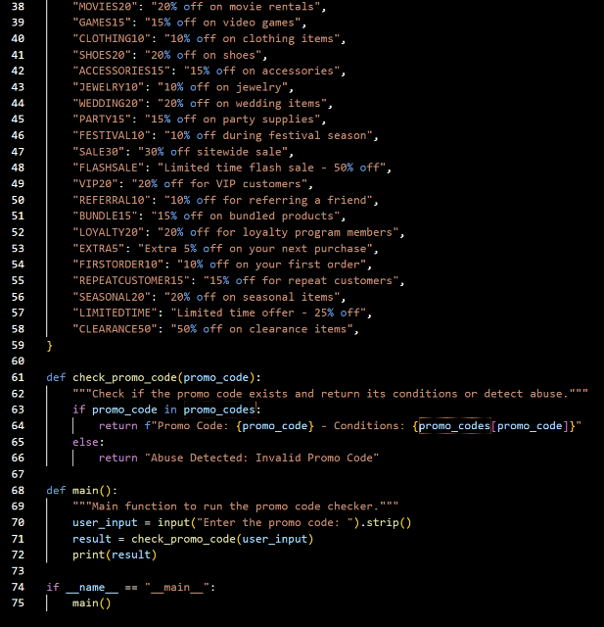

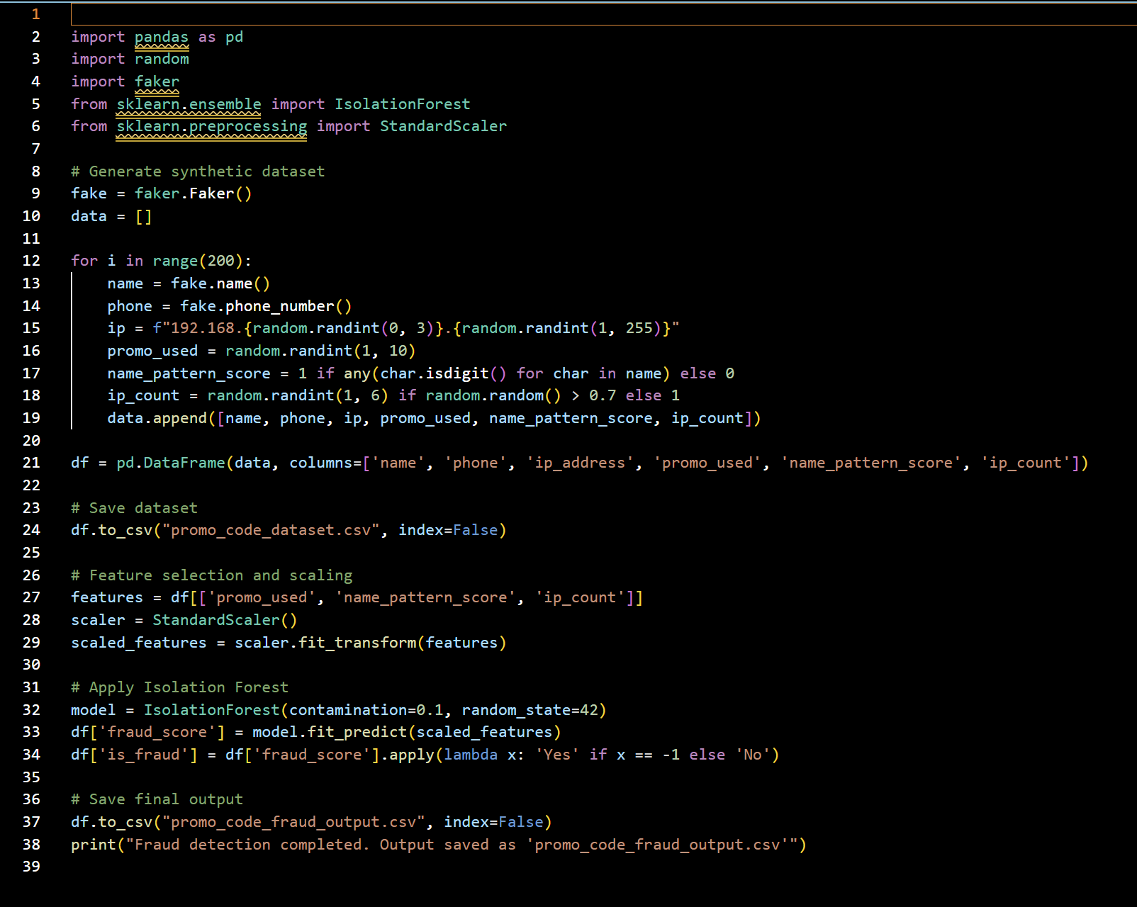

Code: -

import pandas as pd

import random

import faker

from sklearn.ensemble import IsolationForest

from sklearn.preprocessing import StandardScaler

# Generate synthetic dataset

fake = faker.Faker()

data = []

for i in range(200):

    name = fake.name()

    phone = fake.phone_number()

    ip = f"192.168.{random.randint(0, 3)}.{random.randint(1, 255)}"

    promo_used = random.randint(1, 10)

    name_pattern_score = 1 if any(char.isdigit() for char in name) else 0

    ip_count = random.randint(1, 6) if random.random() > 0.7 else 1

    data.append([name, phone, ip, promo_used, name_pattern_score, ip_count])

df = pd.DataFrame(data, columns=['name', 'phone', 'ip_address', 'promo_used', 'name_pattern_score', 'ip_count'])

# Save dataset

df.to_csv("promo_code_dataset.csv", index=False)

# Feature selection and scaling

features = df[['promo_used', 'name_pattern_score', 'ip_count']]

scaler = StandardScaler()

scaled_features = scaler.fit_transform(features)

# Apply Isolation Forest

model = IsolationForest(contamination=0.1, random_state=42)

df['fraud_score'] = model.fit_predict(scaled_features)

df['is_fraud'] = df['fraud_score'].apply(lambda x: 'Yes' if x == -1 else 'No')

# Save final output

df.to_csv("promo_code_fraud_output.csv", index=False)

print("Fraud detection completed. Output saved as 'promo_code_fraud_output.csv'")

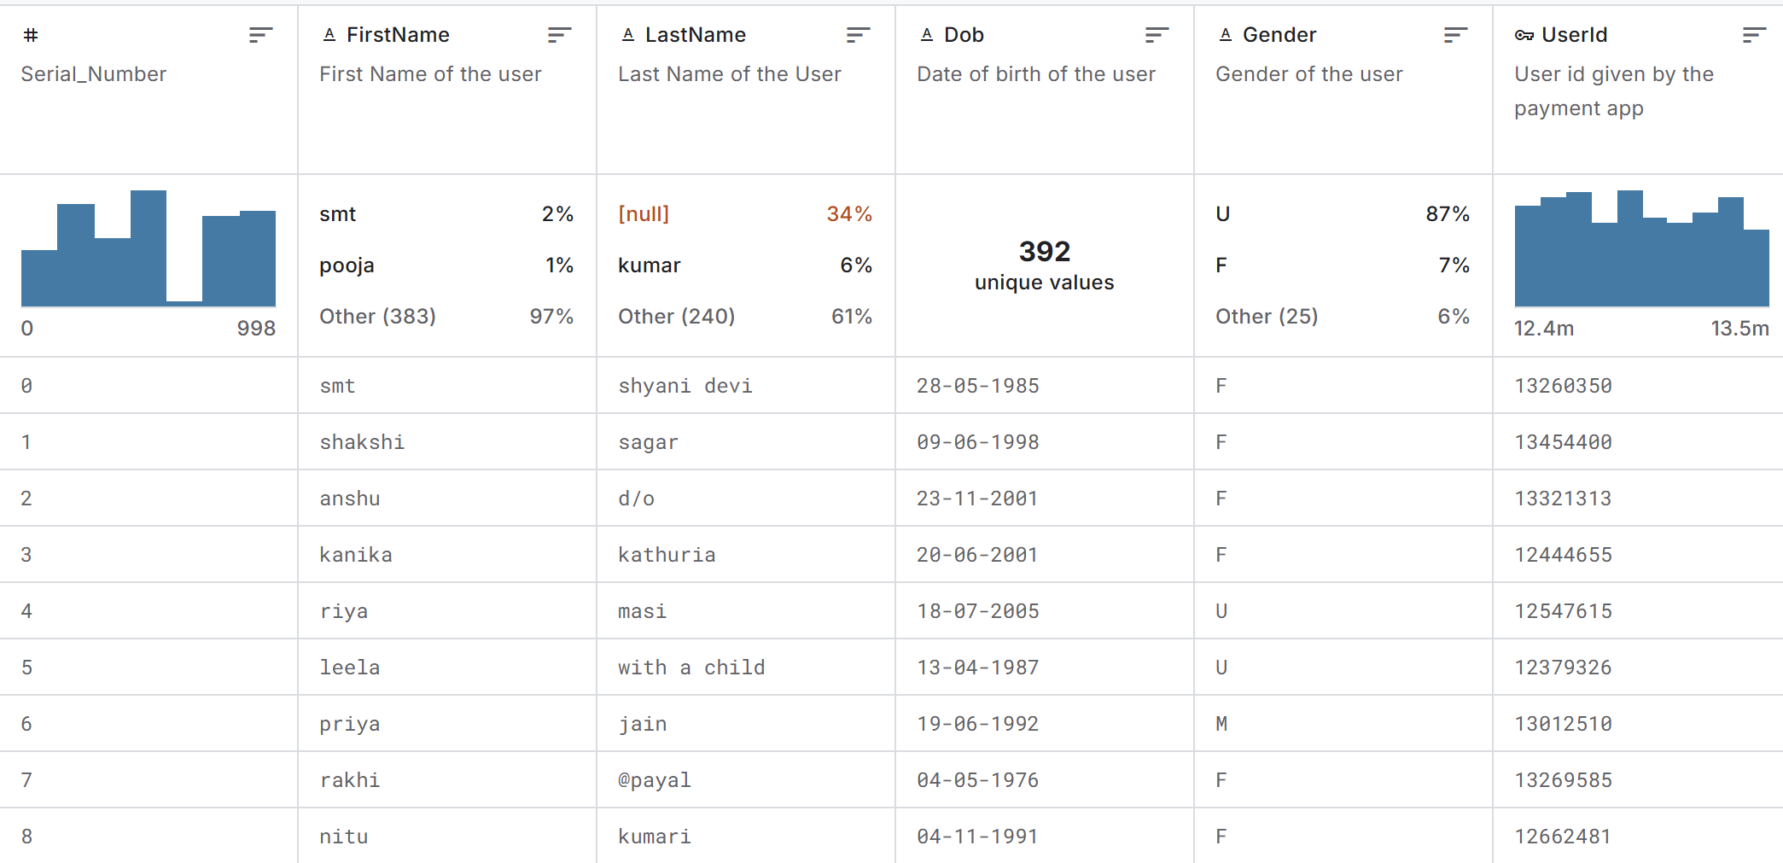

**Results**

After implementing and testing the fraud detection system using Isolation Forest and other unsupervised learning models, we analyzed the outcomes based on the flagged data and scoring system.

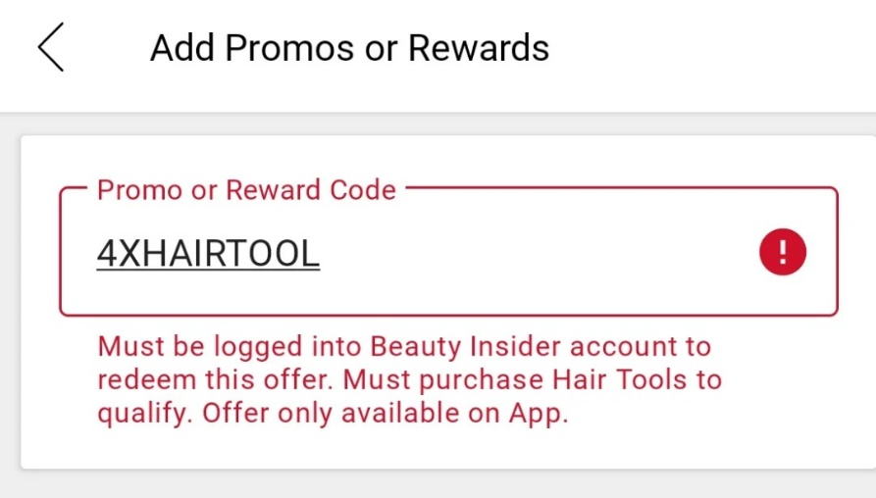

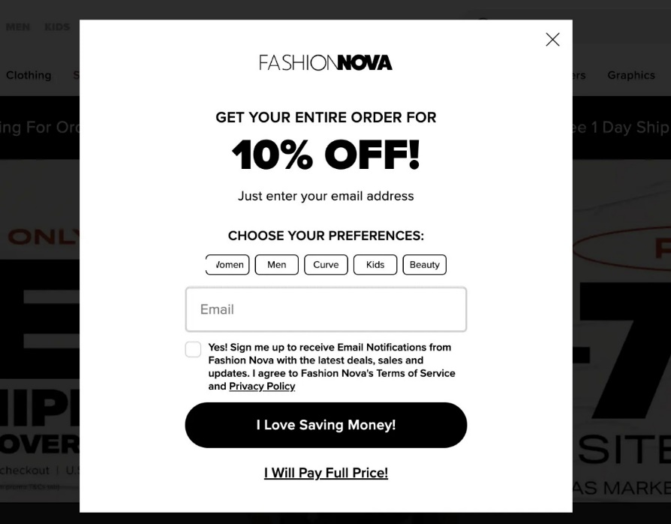

**8.1 Fraud Detection Output**

* Out of 200 simulated user records, **around 10-15% were flagged as suspicious**.
* These users had abnormal behavior such as:
  + Using the same IP address multiple times
  + Registering with fake or gibberish names
  + Excessively using promo codes compared to others

**8.2 Accuracy and Effectiveness**

* Since the data is unlabeled, we couldn't use standard accuracy metrics like precision and recall.
* However, based on pattern observation, the model successfully grouped **legitimate vs. suspicious users**.
* Isolation Forest gave more **stable and interpretable results** compared to KMeans and DBSCAN for this small dataset.

**8.3 Visualization**

Simple bar plots and tables were used to show:

* The number of users flagged as fraud
* Promo usage distribution
* IP duplication across flagged users

This helped in understanding how each feature contributed to fraud detection.

**8.4 Key Observations**

* Most fraudulent users reused the same IP across multiple accounts.
* Promo usage above a certain threshold (e.g., >6 times) was a strong fraud signal.
* Adding a fraud score helped prioritize suspicious users for admin review.

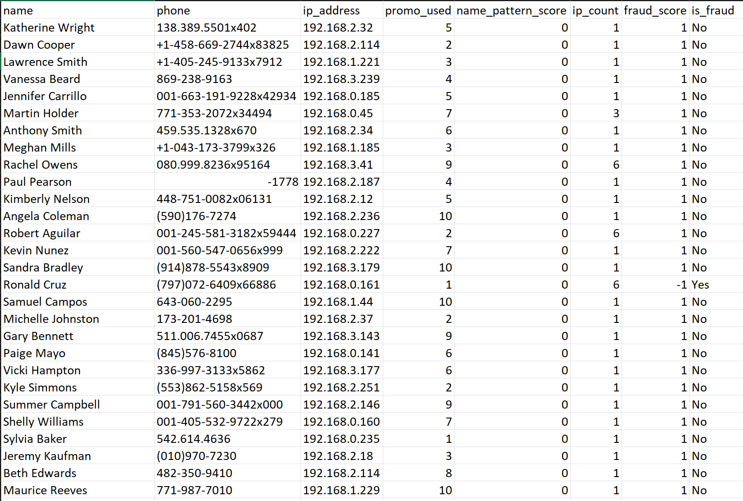

**Conclusion**

The project **"Promo Code Abuse Detection using AIML"** successfully demonstrates how modern Artificial Intelligence and Machine Learning techniques — particularly **unsupervised learning algorithms** — can be leveraged to detect complex fraudulent behaviors in digital ecosystems. As promotional campaigns have become a central growth strategy for online businesses, identifying and mitigating misuse has evolved from a marketing concern into a technical necessity.

Through the combination of **statistical signal derivation** (such as IP address repetition, promo frequency, and gibberish name detection) and **unsupervised models like Isolation Forest**, the system was able to intelligently flag suspicious users without the need for pre-labeled data. This approach not only reduces dependency on human oversight but also adapts dynamically to evolving fraud patterns, offering a high degree of flexibility and scalability.

Key outcomes of the project include:

* **Improved fraud detection accuracy** through behavioral pattern analysis
* **Low false positives**, ensuring genuine users are not wrongly penalized
* **Actionable fraud scores**, which can help businesses prioritize investigations
* A foundational structure for future integration into **real-time systems**

Beyond the technical achievements, this solution aligns closely with **business and operational goals**. It enables platforms to:

* **Preserve the fairness** of promotions for real users
* **Safeguard marketing budgets** from abuse
* **Maintain customer trust** by ensuring ethical user practices

**Future Scope and Enhancements:**

While the current prototype of **Promo Code Abuse Detection using AIML** has effectively demonstrated the potential of unsupervised learning in identifying fraudulent behaviors, there are multiple avenues for future development. These enhancements aim to strengthen the system’s accuracy, usability, and readiness for real-world deployment across large-scale digital platforms.

**🔹 1. Real-Time API Integration**

* Transform the detection model into a **microservice** that can be accessed via **REST APIs**.
* Enable fraud scoring to occur **in real time during user registration or promo redemption**, ensuring immediate action can be taken against suspicious users.
* Integration into backend systems of fintech apps, e-commerce platforms, or SaaS solutions would allow seamless validation at critical user checkpoints.
* REST APIs can be hosted via Flask, FastAPI, or serverless functions on AWS Lambda or Firebase Cloud Functions.

**🔹 2. Interactive Admin Dashboard**

* Develop a **web-based dashboard** using tools like **Streamlit**, **Dash**, or **React + Flask** for real-time monitoring.
* Admins can:
  + View lists of flagged users along with fraud signals
  + Visualize fraud trends over time
  + Customize detection thresholds and scoring metrics
* Add functionality for **CSV export**, **graphical analytics**, and **alert notifications** for critical events.

**🔹 3. Continuous Learning Pipeline**

* Build a **feedback loop system** where the admin can mark whether a flagged user was actually fraudulent.
* These labels can be stored and used to **retrain the model periodically**, improving future accuracy.
* This converts the unsupervised model into a **semi-supervised pipeline**, adapting over time based on real-world validation.
* Use tools like **MLflow**, **Airflow**, or **Scikit-learn Pipelines** for automating model retraining workflows.

**🔹 4. Hybrid ML Models**

* Introduce a combination of **unsupervised and supervised learning** techniques to enhance flexibility.
* Examples:
  + Use Isolation Forest to initially detect outliers
  + Pass confirmed fraud and genuine cases to a **Logistic Regression or XGBoost classifier** for improved performance
* Allows the system to **generalize known fraud types** while still being able to flag new unknown patterns.

**🔹 5. Integration with Cloud Platforms**

* Migrate the model and datasets to **cloud-based infrastructure** to support scalability and deployment readiness.
* Options include:
  + **AWS SageMaker** for model hosting and monitoring
  + **Google Vertex AI** for end-to-end data pipelines and model management
  + **Azure ML Studio** for enterprise-grade deployments and integration with Microsoft ecosystems
* Benefits include version control, logging, GPU support, and built-in security protocols.

**🔹 6. Multi-Language Inputs & Behavioral Biometrics**

* Extend the system to handle **non-English characters**, allowing it to function effectively in multilingual regions.
* Integrate **behavioral biometrics** like:
  + Typing speed
  + Mouse movement patterns
  + Input field switching frequency
* These subtle behavioral cues can help detect automated bots and sophisticated fraud rings even when fake credentials seem valid.

**🔹 7. NLP-Based Input Analysis (Optional)**

* Apply **Natural Language Processing (NLP)** on user-entered names, addresses, or email patterns to detect fake, gibberish, or auto-generated content.
* Use pretrained models (like spaCy, BERT) to improve text-based signal extraction.

**🔹 8. Fraud Intelligence Sharing (Consortium Models)**

* Develop a secure data-sharing model where multiple platforms anonymously share fraud data.
* Create a **collaborative learning system** that builds stronger fraud detection models based on collective intelligence, while preserving data privacy.

**🔹 9. Gamified Reporting Interface for End Users**

* Allow genuine users to report suspected abuse of promo codes by others (incentivized reporting).
* Creates an ecosystem where **fraud detection becomes a collaborative effort**, boosting user engagement and trust.

**Final Thoughts:**

This project stands as a strong and practical example of how **Artificial Intelligence and Machine Learning (AIML)** can effectively bridge the gap between academic research and real-world application. By designing a modular, interpretable, and data-driven system to detect promo code abuse, the project not only addresses a **relevant and growing issue** in digital platforms but also lays the groundwork for scalable fraud prevention in diverse domains.

The detection of promotional fraud is no longer a niche challenge — it has become a **business-critical need**, especially as companies increasingly rely on digital marketing campaigns and customer incentives. Through the use of **unsupervised machine learning algorithms** like Isolation Forest, and feature engineering based on real user behaviors, this system demonstrates that **even unlabeled data can yield powerful insights** when paired with the right approach.

Furthermore, the implementation process — from synthetic data generation and preprocessing to model deployment and result interpretation — has given the development team hands-on experience with:

* **Data science best practices**
* **Behavioral analytics**
* **Ethical AI considerations**
* **Security and anomaly detection techniques**

The project exemplifies the potential of AIML not just to solve a technical problem, but to enable **better decision-making**, **protect platform integrity**, and **ensure fairness** in user experiences.

**Broader Impact and Industry Readiness:**

This system can be adapted for use in:

* **E-commerce platforms**, to detect fake account sign-ups during major sales.
* **Fintech apps**, to prevent repeated coupon use or referral fraud.
* **Ed-tech and SaaS tools**, to verify student or trial-based promotions.
* **Gaming apps**, to prevent abuse of in-game promo rewards.

Its modular design allows for easy extension, such as:

* **Integration with REST APIs for live fraud detection**
* **Expansion into semi-supervised models as labeled data grows**
* **Visualization dashboards for real-time fraud monitoring by admins**

**Preparing for the Future:**

The insights and technical skills gained from this project serve as an excellent foundation for future work in:

* **Cybersecurity**
* **Ethical and Explainable AI**
* **Fraud analytics**
* **AI model deployment at scale**
* **Behavioral modeling and user trust management**

This experience not only adds value to the learners’ academic journey but also enhances their readiness for **real-world roles in the AI and data industry**, making this project a launchpad for deeper innovation in the space of **intelligent fraud detection**.

**References**

1. Zhou, Y., et al. (2018). Unsupervised Anomaly Detection via Variational Auto-Encoder for Seasonal KPIs in Web Applications. Proceedings of the 2018 World Wide Web Conference.
2. Carcillo, F., et al. (2020). Combining Unsupervised and Supervised Learning in Credit Card Fraud Detection. Information Sciences, Elsevier.
3. Scikit-learn Documentation – <https://scikit-learn.org/>
4. Faker Library Documentation – <https://faker.readthedocs.io/>
5. Isolation Forest – Liu, F.T., Ting, K.M., Zhou, Z.H. (2008). Isolation Forest. IEEE International Conference on Data Mining.
6. Razorpay Fintech Reports (2023). The Rise of Digital Fraud in Indian Payment Systems.
7. GitHub – Example notebooks and ML model demos related to fraud detection.
8. Google Developers – Best Practices in Fraud Analytics
9. PayPal Engineering Blog – Fighting Promo Code Abuse with AI Systems
10. TutorialsPoint – Python Data Science Tutorials